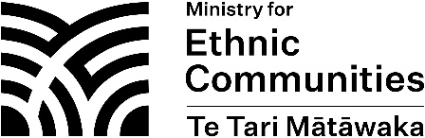
Expression of Interest (EOI) Form – Ethnic Communities Development Fund (ECDF) Panel

Please complete this EOI form as fully as you are able. If you have any questions or difficulties, please contact us at humanresources@ethniccommunities.govt.nz. Extra rows can be inserted in the boxes below as required.
Please note that the submission of an EOI will not necessarily result in an appointment to the ECDF Panel.
Personal details
Title |  | Gender
First Name(s) |  | Mobile phone
Family Name |  | Home phone
Email |  | ☐New Zealand citizen  ☐New Zealand permanent resident (please select one)
Address

Which ethnic group(s) do you identify with? (and iwi affiliation if applicable)

Why are you interested in joining the ECDF Panel?

Please describe your understanding of the aspirations of, and challenges faced by, ethnic communities in Aotearoa New Zealand.

Please describe your knowledge of current government priorities and initiatives in relation to ethnic communities in Aotearoa New Zealand.

Please describe your understanding of community funding programmes in Aotearoa New Zealand.

Board or committee experience (public, private, or the community & voluntary sector)
Name of Board/Committee | Position | Start date | Finish date

Other matters
Have you ever been declared bankrupt, convicted of a criminal offence, or are you currently involved in any court proceedings? If so, please provide further information.

Declaration
I confirm that the information I have given in this EOI form is complete, true and correct.
I authorise the Ministry for Ethnic Communities to verify, at any time, the accuracy of the information I have provided in this form and my accompanying documentation.
In addition, I authorise the Ministry for Ethnic Communities to:
- obtain a copy of any criminal records I may have, held by the Ministry of Justice; and
- carry out a credit check.
If I am appointed, I agree to promptly declare any actual or potential conflict of interest to the Ministry for Ethnic Communities, who will decide how the conflict can best be managed. I also agree to abide by any decisions about the management of that conflict. I acknowledge that, if a conflict cannot be managed, the Chief Executive of the Ministry for Ethnic Communities may reconsider the suitability of my appointment to the ECDF Panel.

Full Legal Name:

Signature:

Date:

Ngā mihi!
Please send the completed copy of this EOI form and your CV to humanresources@ethniccommunities.govt.nz by the closing date.

